CH.04.The Power Reactor Core
1 Introduction 2
2 Core Composition 2
2.1 Light Water Reactors 2
2.2 Heavy Water Reactors 2
2.3 Graphite-Moderated Reactors 2
2.4 RBMK Reactors 2
2.5 Fast Reactors 2
3 Fast Reactor Lattices 2
4 Thermal Reactor Lattices 2
4.1 Thermal Reactor Lattices 2
4.2 Fast Fission Factor 2
4.3 Thermal Utilization and h 2
4.4 k¥ Reconsidered 2
4.5 Pressurized Water Reactor Example 2
5 Problems 3
6 Problems 3

Introduction

- Criticality maintained over:
  - Varying power levels (low level, mid, highest possible power)
  - Fuel lifetime cycle (fresh half used near end of life)
- Thermal energy must be transferred from the core to the outside the core for final utilization

Core Composition
- Wide variety in designs:
  - liquid fuels,
  - pebble bed fuels with coolant/moderator flowing in-between
  - structured: largely cylindrical (most common now):
    - Axial flow of coolants
    - Heat flow from fuels and conducted by its surface to the coolant
- Fuel element diameter (normal to flow) is around 1cm
  - Limits the centerline core temperature
  - Limits power per unit length (q’) (3-25 kW/m)
- Since q’ is limited, higher power means more linear elements (thousands)
- Refueling reactors:
  - Elements are grouped in assemblies to ease replacement
  - Replacement can be done in stages
- Assemblies can be made different:
  - To flatten power generation density within the reactor
  - Reduce central assemblies’ power
  - How?
    - Relative enrichment
    - Control rods
    - Cycles of replacement

- Key Parameters for the design:
  - Linear power density: $q^{'}=\frac{kW}{m}$
  - Coolant/moderator to fuel volumetric ratio: $\frac{V_{x}}{V_{f}}$
  - Average power density of the reactor ${\overline{P}}^{'''} in\frac{MW}{m^{3}}$
  - Thermal power output $P={\overline{P}}^{'''}*V$
  - Volume of the reactor $V in m^{3}$
  - Enrichment of the fuel $\tilde{e} in \%$

Sun’s core power density: $276.5\frac{W}{m^{3}}=0.0002765\frac{MW}{m^{3}}<\frac{1}{4}\frac{kW}{m^{3}}$
Human body: 60kg giving 120 W, say density 1kg/liter density120W/0.060m3 = $2\frac{kW}{m^{3}}$

Light Water Reactors
- Square cells
- Fuel: uranium oxides in zirconium cladding
  - (People abandoned metallic fuels in early stage of nuclear reactors)
  - Cladding is structural and isolates fission products from the coolant/moderator
- Moderator to fuel ratio of around 2:1
  - Slowing down power (watt/cm) is a key to small sizes and volume ratio
  - $SlowingDownPower:\frac{H_{2}O}{D_{2}O}=\frac{1.28}{0.18}=7\sim {\left(\frac{17}{2.4}\right)}^{-1}=7.2$
- PWR/BWR have generally compact sizes:
  - Small volume ratios (from the large slowing down power)
  - Water serving both as coolant and moderator

- Water large absorption thermal neutrons cross section (compared to heavy water $D_{2}O$)
  - It requires enriched uranium: 2-5% (as shown in Table 4.1: 4.2 % )
- Pressures and temperature:
  - PWR: 152. bar 316ºC: secondary coolant circuit
  - BWR: 69.bar 316ºC: only one coolant circuit

- Fuel cycle:
  - batch mode of 1-2 years
  - 20-30% fuel replacement
- Neutron poison:
  - Burnable poison within the fuel: consume in early part of the life cycle,
  - Soluble boron in coolant
  - Retractable control rods
- The neutron poisons are consumed and
  - Thus, they become less effective as time passes
  - This can be optimized because the fuel becomes partially consumed as time passes

Heavy Water Reactors
- Used mainly in Canada and recently in India
  - It can also be called: Pressurized Heavy Water Reactor: PHWR
  - Developed in 1950s in Canada under name CANDU
- Moderator to fuel ratio is large (17:1)
  - $SlowingDownPower:\frac{H_{2}O}{D_{2}O}=\frac{1.28}{0.18}=7\sim {\left(\frac{17}{2.4}\right)}^{-1}=7.2$
- Heavy water has tiny absorption cross section to thermal neutrons cross section
  - It can work with natural uranium avoiding the enrichment process all together!
  - It makes more energy per minded kg of uranium (since you avoid enrichment)
- Heavy water:
  - It exists in ocean as 1:6420 ratio compared to light water
  - It can be purified using distillation as it boils at 101.4C compared to 100C
  - The boiling points of deuterium and hydrogen gas (−249.7°C and −252.5°C) can be used in separation
  - Reactors using heavy water can be used to make plutonium and tritium more easily compared to other reactors
- CANDU
  - Pressure vessel is placed on its side
  - Pressure tubes houses several assemblies or fuel bundles (10cm diameter and 50cm in length for example)
  - The general vessel, calandria, is kept at low pressure
  - Only the fuel tubes are pressurized to prevent boiling of the heavy water
- Fuel
  - It uses natural uranium without enrichment
  - Natural UO2 cannot sustain long operation time
  - Fuel is replaced on continuous basis (i.e. not in batch mode)
  - Each bundle is pushed from one side and used one collected in the other side as shown in the figure bellow (machine operated)
  - More spent fuel compared to light water reactor!
  - Since the fuel serve a shorter time there is a reduced need for neutron poison.
  - Control rods are used for shut down

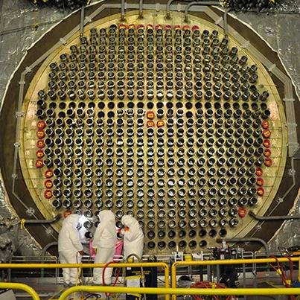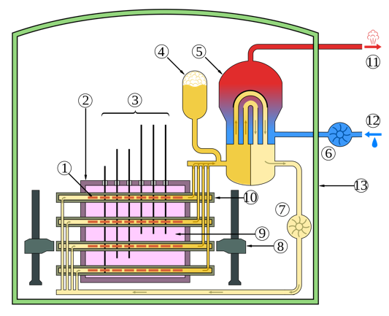

Graphite-Moderated Reactors
- Graphite:
  - slowing down power to be smaller than that of either light or heavy water.
  - Slowing down ratio intermediate between light and heavy water
  - Very large moderator to fuel volume

- Helium coolant combined with partially enriched fuel has led to the design of graphite-moderated power reactors capable of operating at very high temperatures.
  - High temperature enables efficient power or high temperature applications

- The fuel enrichment is quite high (20%)

- The large volume of graphite moderator required causes the HTGR to have the lowest power density

RBMK Reactors
- RBMK: water-cooled, graphite-moderated reactor.
  - liquid coolants that differ from the moderator
  - volumes as large as 1000 m3
  - Core consists of pressure tubes which contain fuel assemblies composed of bundles of
  - cylindrical fuel elements of uranium dioxide in zirconium cladding.
- Refueling:
  - on-line using machines to isolate one pressure tube at a time.
  - Water boils as it moves inside the tube
    - (can it go through density variation?)
  - Unlike CANDU, the tubes are vertical
  - Fuel is enriched (2%)

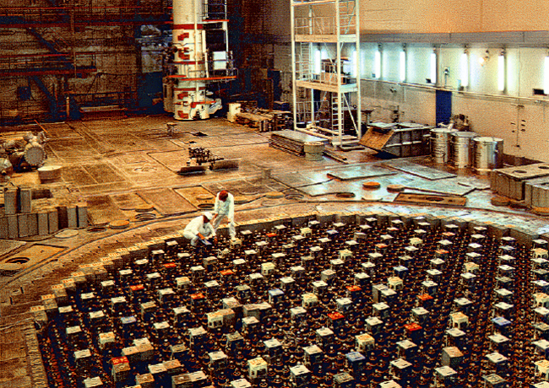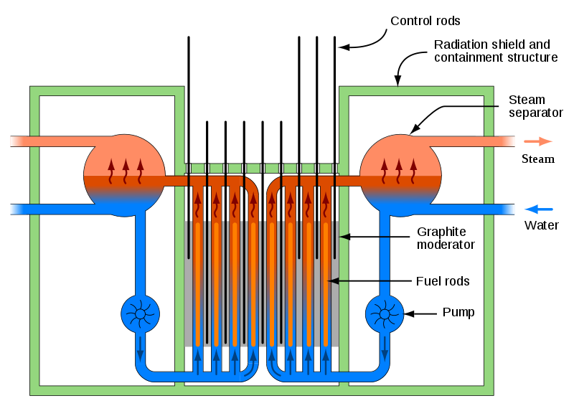

Fast Reactors
- Fast reactor cores contain as little low atomic mass material as possible in order to impede neutron slowing down by elastic scattering.
- Fast reactor fuel may be metal or a ceramic, encapsulated in metal cladding

- Liquid metals:
  - Sodium-cooled fast reactors (SFRs) are the most common designs
  - Some Russian fast reactors have utilized molten lead coolant.

- fast reactor refueling is carried out in batch mode.

Fast Reactor Lattices
- In fast reactors, the energy spectrum is kept narrow as a fast energy range.
- We have the “Infinite Multiplication Factor”, with just energy dependence (spatial is averaged):
- Fast reactor has high enrichment factor >10%
- Low atomic weight (low A) materials are reduced as much as possible to reduce energy degradation/thermalization of fast neutrons
- Since the cross section (fast) is very small (compared to thermal), the neutrons mean free path is very large
  - This makes the energy flux flat over the reactor (spatially flat)
  - The three constituents: fuel, coolant and structural see about the same spectrum.
- To find the multiplication factor for certain enrichment level and coolant to fuel ratio, we proceed:
  - Use volume fractions to average absorption and fission cross section (4.2)
    - $V=V_{f}+V_{c}+V_{st}$
  - Use energy weighted spectrum to evaluate flux averaged cross section
    - The average energy flux (which is around “fast") (4.4)
    - The energy averaging process is stated for each process in (4.5)
  - Enrichment should be accounted for in cross sections
    - (U-235 is still 4-5X higher cross section compared to U-238 in the fast region)

Notes | Equation:
Multiplication factor (assuming a pure materials and known spectrum)
Averaging cross section over different materials (identified by volume fractions)
(cell volume averaging)
Update 4.1 using volume fractions of 4.2

(coolant & structural do not fission)
Computing average flux averaged over the energy dependent flux
Averaging a cross section of process y over the energy flux
Simple combination of 4.5 and 4.4

Energy and cell volume averaging
Multiplication factor expressed using averaging of space and energy
(fuel is assumed as a single material)
Fuel has an enrichment factor
Macroscopic cross section expressed in terms of microscopic one
4.5 expressed in terms of microscopic rather than macroscopic
Macroscopic fission cross section expressed in terms of fissile/fertile microscopic cross sections:
Multiplication factor accounting for:
- Enrichment
- Volume fractions of materials
- Energy spectrum
Re-statement that removes fuel volume from enrichment terms.

Thermal Reactor Lattices
- Fuel pins are several MFP because:
  - Cross sections are large
  - Dimensions of coolant and moderators are large compared to fuel
- This results in significant spatial variation of each energy range.
- The following check table, indicates non-ignored terms:

- Fission happens in fuel only.
- Most fission in fast region and some in fast region
Fission Cross section | Thermal | Intermediate | Fast
Fuel | X |  | X
Moderator

- Absorption happens in thermal region in both fuel and moderator
- Some resonance absorption happens for fuel
Absorption Cross section | Thermal | Intermediate | Fast
Fuel | X | X | *
Moderator | X
(*) fast absorption is ignored not because it does not happen but it is too small compared to thermal and intermediate absorption

- Infinite multiplication factor
  - accounting for materials and energy
  - spatial variation is not accounted for
  - if you include spatial loss of neutrons (through boundary then you are talking about effective mu

The Four Factor Formula

- Where:
  - n: number of neutrons borne fast
  - $ϵ$: fast fission factor:
    - neutrons created on fast regions relative to those in thermal fission +1
    - (total fission events to thermal fission events = 1 + fast/thermal)
    - $ϵ>1 (0.02-0.3)$
  - p: neutrons probability of surviving intermediate absorption to reach thermal
    - p < 1
    - p neutrons reach thermal, (1-p) are captured in resonance region
  - f: thermal utilization
    - f<1
    - f is absorbed by fuel
    - (1-f) absorbed by the moderator
  - $η_{T}$: fast fission factor:
    - $η_{T}>1$
    - Neutron generated to neutrons absorbed
- In result, we model the multiplication using 4 factors formula as:

$$K_{∞}=\frac{ϵ p f η_{T} n}{n}=ϵ p f η_{T}$$
- Comments on Table 4.2
  - $k_{∞}$ is substantially greater than 1
    - It should be true for fresh fuel, no poison.
    - As the fuel is depleted or poisons accumulate, or control rods are in – it is not supercritical
  - Fuel depletion reduces $η_{T}$

- The 4-factors formula does not account for geometric loss through boundary of the system
  - That is why it is infinity criticality factor ($∞$)
  - The loss through boundary is not included
    - It is included on effective multiplication factor or $k_{effective}=\frac{νΣ_{f}}{Σ_{a}+C}$
    - where C is the loss
    - The “finite” core size where loss can occur is accounted for in 6-factors formula

- Remaining parts: examine each factor by proper averaging:

Fast Fission Factor
The fast fission factor estimates the increase in fission neutrons due to fast fission events compared to the case that we only have thermal fission events:

$$\frac{Total fission}{Thermal fission}=\frac{total}{thermal}=\frac{thermal+0+fast}{thermal}=1+\frac{fast}{thermal}$$

Resonance Escape Probability

Absorption Cross section | Thermal | Intermediate | Fast
Fuel | X | X
Moderator | X

- Fast absorption is minimal compared to the other regions
- From the three absorptions in the above table
  - Intermediate absorption does not contribute to fission loss
  - p factor discount it relative to the three:
$$p=\frac{wanted}{total}=\frac{wanted}{wanted+loss}=1-\frac{loss}{wanted+loss}$$

After a few arguments about energy dependence within intermediate steps, p factor is expressed as an energy independent formula and resonance integral formula are given by:

$ξ$: moderator slowing down decrement factor
The detailed modeling can be replaced with the following empirical formula:

I: resonance integral in barns
$ρ:$density in g/cm3
D: the rod diameter in cm (only in 0.2 cm < D < 3.5 cm)

Thermal Utilization and $η_{T}$
Thermal neutrons are either absorbed in the fuel or moderator, the desired fraction is for the fuel to absorb them:
We are interested in the generated neutrons from these general absorptions:
The above expressions can be simplified, if we use average energy spectrum (in the thermal region), and also simplifying the cross sections as well:
Finally, we reach:

Where we define “thermal disadvantage factor”: ratio of thermal neutron flux in the moderator to that in the fuel

$k_{∞}$Reconsidered
If the four factors formula (can be evaluated for a given reactor configuration) are multiplied, the original formula (difficult to compute directly) is re-derived:
$$K_{∞}=\frac{ϵ p f η_{T} n}{n}=ϵ p f η_{T}$$

Pressurized Water Reactor Example
- The two key design features:
  - Enrichment of the fuel
  - Moderator to fuel volume ratio
- Infinite multiplication factor, $k_{∞}$, increases with enrichment, with some maximum affected by volume ratio
- You could have under-moderated or over-moderated

- We express the four factors in terms of:
  - 1) enrichment,
  - 2) moderator to fuel volume ratio

- On purpose, the design is under-moderated in liquid moderated reactor
- As $T ↑$,
  - Moderator volume increases
  - Moderator volume to fuel ratio decreases (negative feedback)
- In solid moderated or solid-liquid moderated reactor
  - The design is not simple and complex behavior must be modeled

Factor | Original Formula | Simplified | Expressed enrichment/volumes
$$ϵ$$
p
f
$$η_{T}$$

Problems

https://en.wikipedia.org/wiki/Solar_core
The book by mistake states that the pressure 1520. Bar a mistake of converting 2200psi. The butane gas tank used for domestic cooking is 26bar. The water critical pressure is 217.7bar. It should be obvious that water is kept bellow the critical point conditions in both temperature and pressure: $P_{w,c}=22.09 MPa, T_{cr}=374.14°C, V_{cr}=3.155 liter/kg,$ (link)
$f=\frac{wanted}{total}=\frac{wanted}{wanted+loss}$
It is not desired that thermal neutrons are fluxing around in the moderator rather than the fuel. We cannot control this behavior unfortunately!

